Lab - Basic Switch and End Device Configuration

~~Aim:~~

~~The aim of the lab practical is to facilitate the learner to explore the development of a simple network with two hosts and two switches. Configure the network with basic settings, use various commands to display the running configuration and finally save the settings. The learner is required to apply IP addressing to the devices to enable communication and ultimately test the network using a simple Ping to verify connectivity.~~

* ~~While following the instructions within this tutorial, you are required to answer a number of questions presented including the completion of a table on page 8.~~
* ~~Take a number of screenshots as you progress in the tutorial.~~
* ~~Finally, under the heading “Reflection” and “Theory” additional discussion questions are added. You are required to submit answers to the questions presented.~~

~~Upload Requirements: (please upload the following):~~

* ~~The initial word document with the answers to the questions presented as you progress through this tutorial.~~
* ~~This also includes the final analysis questions presented at the end of the document “Reflection questions” and “Theory questions”.~~
* ~~A minimum of four screenshots, attached to the same word document.~~
* ~~Plus, the completed~~ *~~Packet Tracer Activity~~* ~~file.~~

# Topology

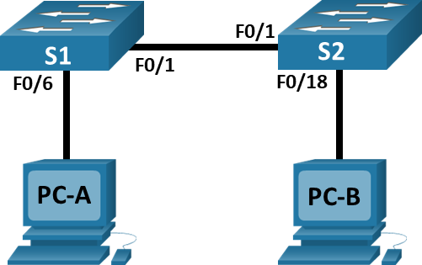

# Addressing Table

|  |  |  |  |
| --- | --- | --- | --- |
| Device | Interface | IP Address | Subnet Mask |
| S1 (Room-200) | VLAN 1 | 192.168.1.1 | 255.255.255.0 |
| S2 (IRoom-210) | VLAN 1 | 192.168.1.2 | 255.255.255.0 |
| PC-A (Manager) | NIC | 192.168.1.10 | 255.255.255.0 |
| PC-B (Reception) | NIC | 192.168.1.11 | 255.255.255.0 |

# Objectives

* ~~Set Up the Network Topology~~
* ~~Configure PC Hostnames and IP addresses~~
* ~~Configure and Verify Basic Switch Settings~~

# Background / Scenario

~~In this lab, you will build a simple network with two hosts and two switches. You will also configure basic settings including hostname, local passwords, and login banner. Use~~ **~~show~~** ~~commands to display the running configuration, IOS version, and interface status. Use the~~ **~~copy~~** ~~command to save device configurations.~~

~~You will apply IP addressing for this lab to the PCs and switches to enable communication between the devices. Use the~~ **~~ping~~** ~~utility to verify connectivity.~~

**~~Note~~**~~: The switches used are Cisco Catalyst 2960s with Cisco IOS Release 15.0(2) (lanbasek9 image). Other switches and Cisco IOS versions can be used. Depending on the model and Cisco IOS version, the commands available and output produced might vary from what is shown in the labs.~~

# Required Resources

* **~~2 Switches (Cisco~~****~~2960~~** ~~with Cisco IOS Release 15.0(2) lanbasek9 image or comparable)~~
* **~~2 PCs~~** ~~(Windows with terminal emulation program, such as Tera Term)~~
* ~~Console cables to configure the Cisco IOS devices via the console ports~~
* ~~Ethernet cables as shown in the topology~~

# Instructions

## ~~Set Up the Network Topology~~

~~In this step, you will cable the devices together according to the network topology.~~

* + 1. ~~Create a PT activity file and drag and drop the various devices onto the file.~~
    2. ~~Power on the devices by connecting the various cables required. Each device will power on automatically, once connected.~~
    3. ~~Connect the two switches. (use a Copper Cross-Over cable from FastEthernet0/1 port on S1 to FastEthernet0/1 port on S2)~~
    4. ~~Connect the PCs to their respective switches. (use a Copper Straight-Through from FastEthernet0/6 on S1 to FastEthernet0 port on PC-A; then FastEthernet0/18 on S2 to FastEthernet0 port on PC-B).~~
    5. ~~Visually inspect network connections. (Initially when you connect devices to a switch port, the link lights will be amber, after a minute the link lights will turn green).~~

## ~~Configure PC Hosts~~

* + 1. ~~Configure static IP address information on the PCs according to the Addressing Table.~~

~~(PC-A 🡪Desktop🡪IP Configuration; enter Host name, IP and Subnet Mask address, then close. Repeat for PC-B)~~

* + 1. ~~Verify PC settings and connectivity.~~

~~(to verify: click PC-A 🡪Desktop🡪Command Prompt. Use the~~ **~~ipconfig /all~~** ~~command at the prompt to verify settings. Then enter a ping from PC-A to PC-B, repeat from PC-B to PC-A.~~

**~~This should appear after each command entered:~~**

~~From PC-A, open a Command Prompt to verify the PC settings and connectivity using the ipconfig /all command at the prompt.~~

~~C:\Users\Student>~~ **~~ipconfig /all~~**

**~~The following image is an example of what you may expect to be illustrated~~.**

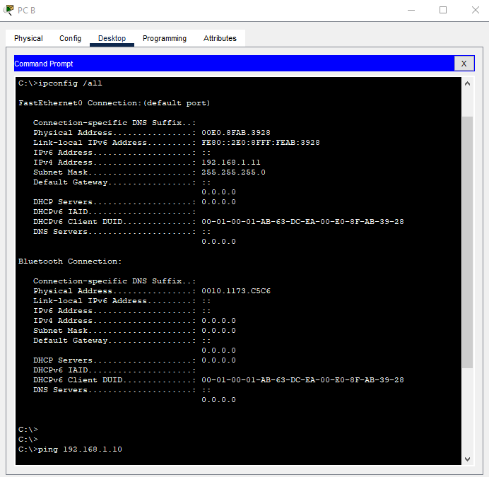

~~To test the connectivity to PC-B, enter ping 192.168.1.11 at the prompt. The ping should be successful. If not, troubleshoot as necessary.~~

~~C:\Users\Student>~~ **~~ping 192.168.1.11~~**

**~~Expected Output:~~**

~~Pinging 192.168.1.11 with 32 bytes of data:~~

~~Reply from 192.168.11: bytes=32 time<1ms TTL=128~~

~~Reply from 192.168.11: bytes=32 time<1ms TTL=128~~

~~Reply from 192.168.11: bytes=32 time<1ms TTL=128~~

~~Reply from 192.168.11: bytes=32 time<1ms TTL=128~~

~~Ping statistics for 192.168.1.11:~~

~~Packets: Sent = 4, Received = 4, Lost = 0 (0% loss),~~

~~Approximate round trip times in milli-seconds:~~

~~Minimum = 0ms, Maximum = 0ms, Average = 0ms~~

**Q: What was the Round-Trip time recorded from your ping?**

From PC-A to PC-B: Minimum = 0ms, Maximum = 0ms, Average = 0ms

From PC-B to PC-A: Minimum = 0ms, Maximum = 0ms, Average = 0ms  
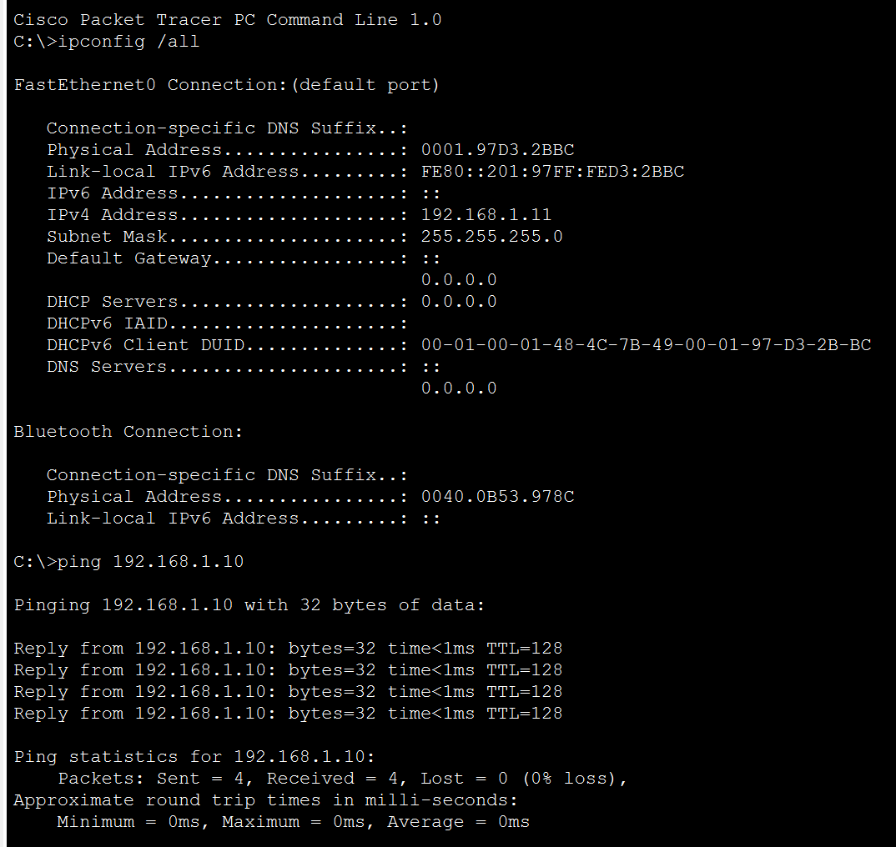

## ~~Configure and Verify Basic Switch Settings~~

* + 1. ~~Console into the switch. Enter the global configuration mode.~~

~~Open Configuration Window~~

~~Establish a console connection to the switch from PC-A.~~

~~You can access all switch commands in privileged EXEC mode. The privileged EXEC command set includes those commands contained in user EXEC mode, as well as the configure command through which access to the remaining command modes are gained.~~

~~Click on S1 🡪the select the CLI tab~~

~~Enter privileged EXEC mode by entering the enable command.~~

**~~Switch> enable~~**

**~~Switch#~~**

~~The prompt changed from Switch> to Switch# which indicates privileged EXEC mode.~~

~~Use the configuration terminal command to enter configuration mode.~~

~~Switch#~~ **~~configure terminal~~**

**Output on screen:**

**~~Enter configuration commands, one per line. End with CNTL/Z.~~**

**~~Switch(config)#~~**

~~The prompt changed to reflect global configuration mode.~~

* + 1. ~~Give the switch a name according to the Addressing Table.~~

~~Use the hostname command to change the switch name to S1.~~

~~Switch(config)#~~ **~~hostname S1~~**

* + 1. ~~Prevent unwanted DNS lookups.~~

~~To prevent the switch from attempting to translate incorrectly entered commands as though they were hostnames, disable the Domain Name System (DNS) lookup.~~

~~S1(config)#~~ **~~no ip domain-lookup~~**

* + 1. ~~Enter local passwords. Use “~~**~~class”~~** ~~as the privileged EXEC password and “~~**~~cisco~~**~~” as the password for console access.~~

~~To prevent unauthorized access to the switch, configure passwords as follows:~~

~~S1(config)#~~ **~~enable secret class~~**

~~S1(config)#~~ **~~line con 0~~**

~~S1(config-line)#~~ **~~password cisco~~**

~~S1(config-line)#~~ **~~login~~**

~~S1(config-line)#~~ **~~exit~~**

* + 1. ~~Configure and enable the SVI according to the Addressing Table.~~

~~S1(config)#~~ **~~interface vlan 1~~**

~~S1(config-if)#~~ **~~ip address 192.168.1.1 255.255.255.0~~**

~~S1(config-if)#~~ **~~no shut~~**

* + 1. Enter a login MOTD banner to warn about unauthorized access.

A login banner, known as the message of the day (MOTD) banner, should be configured to warn anyone accessing the switch that unauthorized access will not be tolerated.

The banner motd command requires the use of delimiters to identify the content of the banner message. The delimiting character can be any character as long as it does not occur in the message. For this reason, symbols, such as the #, are often used.

~~S1(config)#~~ **~~banner motd #~~**

**~~Output expected:~~**

~~Enter TEXT message. End with the character '#'.~~

**~~Then enter the following:~~**

**~~Unauthorized access is strictly prohibited and prosecuted to the full extent of the law. #~~**

~~S1(config)#~~ **~~exit~~**

* + 1. ~~Save the configuration.~~

~~Use the copy command to save the running configuration to the startup file on non-volatile random access memory (NVRAM).~~

~~S1#~~ **~~copy running-config startup-config~~**

~~Destination filename [startup-config]?~~ **~~[Press Enter]~~**

~~Building configuration...~~

~~[OK]~~

~~S1#~~

* + 1. ~~Display the current configuration.~~

~~The show running-config command displays the entire running configuration, one page at a time. Use the spacebar to advance paging. The commands configured in Steps a - h are highlighted below.~~

~~S1#~~ **~~show running-config~~**

~~Building configuration...~~

**~~Expected output: (may differ slightly)~~**

**~~Look for the highlighted commands that were configured in the earlier steps (highlighted in Blue)~~**

~~Current configuration : 1409 bytes~~

~~!~~

~~! Last configuration change at 03:49:17 UTC Mon Mar 1 1993~~

~~!~~

~~version 15.0~~

~~no service pad~~

~~service timestamps debug datetime msec~~

~~service timestamps log datetime msec~~

~~no service password-encryption~~

~~!~~

~~hostname S1~~

~~!~~

~~boot-start-marker~~

~~boot-end-marker~~

~~!~~

~~enable secret 4 06YFDUHH61wAE/kLkDq9BGho1QM5EnRtoyr8cHAUg.2~~

~~!~~

~~no aaa new-model~~

~~system mtu routing 1500~~

~~!~~

~~no ip domain-lookup~~

~~<output omitted……………>~~

~~interface Vlan 1~~

~~ip address 192.168.1.1 255.255.255.0~~

~~ip http server~~

~~ip http secure-server~~

~~!~~

~~banner motd ^C~~

~~Unauthorized access is strictly prohibited and prosecuted to the full extent of the law. ^C~~

~~!~~

~~line con 0~~

~~password cisco~~

~~login~~

~~line vty 0 4~~

~~login~~

~~line vty 5 15~~

~~login~~

~~!~~

~~end~~

* + 1. ~~Display the IOS version and other useful switch information.~~

~~Use the show version command to display the IOS version that the switch is running, along with other useful information. Again, you will need to use the spacebar to advance through the displayed information.~~

~~S1#~~ **~~show version~~**

**~~Expected output:~~**

~~Cisco IOS Software, C2960 Software (C2960-LANBASEK9-M), Version 15.0(2)SE, RELEASE SOFTWARE (fc1)~~

~~Technical Support: http://www.cisco.com/techsupport~~

~~Copyright (c) 1986-2012 by Cisco Systems, Inc.~~

~~Compiled Sat 28-Jul-12 00:29 by prod_rel_team~~

~~ROM: Bootstrap program is C2960 boot loader~~

~~BOOTLDR: C2960 Boot Loader (C2960-HBOOT-M) Version 12.2(53r)SEY3, RELEASE SOFTWARE (fc1)~~

~~S1 uptime is 1 hour, 38 minutes~~

~~System returned to ROM by power-on~~

~~System image file is "flash:/c2960-lanbasek9-mz.150-2.SE.bin"~~

~~This product contains cryptographic features and is subject to United~~

~~States and local country laws governing import, export, transfer and~~

~~use. Delivery of Cisco cryptographic products does not imply~~

~~third-party authority to import, export, distribute or use encryption.~~

~~Importers, exporters, distributors and users are responsible for~~

~~compliance with U.S. and local country laws. By using this product you~~

~~agree to comply with applicable laws and regulations. If you are unable~~

~~to comply with U.S. and local laws, return this product immediately.~~

~~A summary of U.S. laws governing Cisco cryptographic products may be found at:~~

~~http://www.cisco.com/wwl/export/crypto/tool/stqrg.html~~

~~If you require further assistance please contact us by sending email to~~

~~export@cisco.com.~~

~~cisco WS-C2960-24TT-L (PowerPC405) processor (revision R0) with 65536K bytes of memory.~~

~~Processor board ID FCQ1628Y5LE~~

~~Last reset from power-on~~

~~1 Virtual Ethernet interface~~

~~24 FastEthernet interfaces~~

~~2 Gigabit Ethernet interfaces~~

~~The password-recovery mechanism is enabled.~~

~~64K bytes of flash-simulated non-volatile configuration memory.~~

~~Base ethernet MAC Address : 0C:D9:96:E2:3D:00~~

~~Motherboard assembly number : 73-12600-06~~

~~Power supply part number : 341-0097-03~~

~~Motherboard serial number : FCQ16270N5G~~

~~Power supply serial number : DCA1616884D~~

~~Model revision number : R0~~

~~Motherboard revision number : A0~~

~~Model number : WS-C2960-24TT-L~~

~~System serial number : FCQ1628Y5LE~~

~~Top Assembly Part Number : 800-32797-02~~

~~Top Assembly Revision Number : A0~~

~~Version ID : V11~~

~~CLEI Code Number : COM3L00BRF~~

~~Hardware Board Revision Number : 0x0A~~

~~Switch Ports Model SW Version SW Image~~

~~------ ----- ----- ---------- ----------~~

~~* 1 26 WS-C2960-24TT-L 15.0(2)SE C2960-LANBASEK9-M~~

~~Configuration register is 0xF~~

* + 1. ~~Display the status of the connected interfaces on the switch.~~

~~To check the status of the connected interfaces, use the show ip interface brief command. Press the spacebar to advance to the end of the list.~~

~~S1#~~ **~~show ip interface brief~~**

**~~Expected output: (maybe slightly different – look for the Vlan1 setting)~~**

~~Interface IP-Address OK? Method Status Protocol~~

~~Vlan1 192.168.1.1 YES unset up up~~

~~FastEthernet0/1 unassigned YES unset up up~~

~~FastEthernet0/2 unassigned YES unset down down~~

~~FastEthernet0/3 unassigned YES unset down down~~

~~FastEthernet0/4 unassigned YES unset down down~~

~~FastEthernet0/5 unassigned YES unset down down~~

~~FastEthernet0/6 unassigned YES unset up up~~

~~FastEthernet0/7 unassigned YES unset down down~~

~~FastEthernet0/8 unassigned YES unset down down~~

~~FastEthernet0/9 unassigned YES unset down down~~

~~FastEthernet0/10 unassigned YES unset down down~~

~~FastEthernet0/11 unassigned YES unset down down~~

~~FastEthernet0/12 unassigned YES unset down down~~

~~FastEthernet0/13 unassigned YES unset down down~~

~~FastEthernet0/14 unassigned YES unset down down~~

~~FastEthernet0/15 unassigned YES unset down down~~

~~FastEthernet0/16 unassigned YES unset down down~~

~~FastEthernet0/17 unassigned YES unset down down~~

~~FastEthernet0/18 unassigned YES unset down down~~

~~FastEthernet0/19 unassigned YES unset down down~~

~~FastEthernet0/20 unassigned YES unset down down~~

~~FastEthernet0/21 unassigned YES unset down down~~

~~FastEthernet0/22 unassigned YES unset down down~~

~~FastEthernet0/23 unassigned YES unset down down~~

~~FastEthernet0/24 unassigned YES unset down down~~

~~GigabitEthernet0/1 unassigned YES unset down down~~

GigabitEthernet0/2 unassigned YES unset down down Close Configuration Window.

* TAKE A SCREENSHOT OF YOUR OUTPUTS

**~~Well done, now look at Switch 2:~~**

* + 1. ~~Configure switch S2.~~

~~Repeat the previous steps for Switch S2. Make sure the hostname is configured as S2.~~

# Device Configs The following are the expected outputs when you have configured both S1 and S2

# Switch S1 (complete)

~~S1#sh run~~

~~Building configuration...~~

~~Current configuration : 1514 bytes~~

~~version 15.0~~

~~no service pad~~

~~service timestamps debug datetime msec~~

~~service timestamps log datetime msec~~

~~no service password-encryption~~

~~!~~

~~hostname S1~~

~~boot-start-marker~~

~~boot-end-marker~~

~~!~~

~~enable secret 4 06YFDUHH61wAE/kLkDq9BGho1QM5EnRtoyr8cHAUg.2~~

~~!~~

~~no aaa new-model~~

~~system mtu routing 1500~~

~~!~~

~~no ip domain-lookup~~

~~!~~

~~spanning-tree mode pvst~~

~~spanning-tree extend system-id~~

~~!~~

~~vlan internal allocation policy ascending~~

~~!~~

~~interface FastEthernet0/1~~

~~!~~

~~interface FastEthernet0/2~~

~~!~~

~~interface FastEthernet0/3~~

~~!~~

~~interface FastEthernet0/4~~

~~!~~

~~interface FastEthernet0/5~~

~~!~~

~~interface FastEthernet0/6~~

~~!~~

~~interface FastEthernet0/7~~

~~!~~

~~interface FastEthernet0/8~~

~~!~~

~~interface FastEthernet0/9~~

~~!~~

~~interface FastEthernet0/10~~

~~!~~

~~interface FastEthernet0/11~~

~~!~~

~~interface FastEthernet0/12~~

~~!~~

~~interface FastEthernet0/13~~

~~!~~

~~interface FastEthernet0/14~~

~~!~~

~~interface FastEthernet0/15~~

~~!~~

~~interface FastEthernet0/16~~

~~!~~

~~interface FastEthernet0/17~~

~~!~~

~~interface FastEthernet0/18~~

~~!~~

~~interface FastEthernet0/19~~

~~!~~

~~interface FastEthernet0/20~~

~~!~~

~~interface FastEthernet0/21~~

~~!~~

~~interface FastEthernet0/22~~

~~!~~

~~interface FastEthernet0/23~~

~~!~~

~~interface FastEthernet0/24~~

~~!~~

~~interface GigabitEthernet0/1~~

~~!~~

~~interface GigabitEthernet0/2~~

~~!~~

~~interface Vlan1~~

~~ip address 192.168.1.1 255.255.255.0~~

~~!~~

~~ip http server~~

~~ip http secure-server~~

~~!~~

~~banner motd ^C~~

~~Unauthorized access is strictly prohibited and prosecuted to the full extent of the law. ^C~~

~~!~~

~~line con 0~~

~~password cisco~~

~~login~~

~~line vty 0 4~~

~~login~~

~~line vty 5 15~~

~~login~~

~~end~~

# Switch S2 (complete)

~~S2# sh run~~

~~Building configuration...~~

~~Current configuration : 1514 bytes~~

~~!~~

~~version 15.0~~

~~no service pad~~

~~service timestamps debug datetime msec~~

~~service timestamps log datetime msec~~

~~no service password-encryption~~

~~!~~

~~hostname S2~~

~~!~~

~~boot-start-marker~~

~~boot-end-marker~~

~~!~~

~~enable secret 4 06YFDUHH61wAE/kLkDq9BGho1QM5EnRtoyr8cHAUg.2~~

~~!~~

~~no aaa new-model~~

~~system mtu routing 1500~~

~~!~~

~~no ip domain-lookup~~

~~!~~

~~spanning-tree mode pvst~~

~~spanning-tree extend system-id~~

~~!~~

~~vlan internal allocation policy ascending~~

~~!~~

~~interface FastEthernet0/1~~

~~!~~

~~interface FastEthernet0/2~~

~~!~~

~~interface FastEthernet0/3~~

~~!~~

~~interface FastEthernet0/4~~

~~!~~

~~interface FastEthernet0/5~~

~~!~~

~~interface FastEthernet0/6~~

~~!~~

~~interface FastEthernet0/7~~

~~!~~

~~interface FastEthernet0/8~~

~~!~~

~~interface FastEthernet0/9~~

~~!~~

~~interface FastEthernet0/10~~

~~!~~

~~interface FastEthernet0/11~~

~~!~~

~~interface FastEthernet0/12~~

~~!~~

~~interface FastEthernet0/13~~

~~!~~

~~interface FastEthernet0/14~~

~~!~~

~~interface FastEthernet0/15~~

~~!~~

~~interface FastEthernet0/16~~

~~!~~

~~interface FastEthernet0/17~~

~~!~~

~~interface FastEthernet0/18~~

~~!~~

~~interface FastEthernet0/19~~

~~!~~

~~interface FastEthernet0/20~~

~~!~~

~~interface FastEthernet0/21~~

~~!~~

~~interface FastEthernet0/22~~

~~!~~

~~interface FastEthernet0/23~~

~~!~~

~~interface FastEthernet0/24~~

~~!~~

~~interface GigabitEthernet0/1~~

~~!~~

~~interface GigabitEthernet0/2~~

~~!~~

~~interface Vlan1~~

~~ip address 192.168.1.2 255.255.255.0~~

~~!~~

~~ip http server~~

~~ip http secure-server~~

~~!~~

~~banner motd ^C~~

~~Unauthorized access is strictly prohibited and prosecuted to the full extent of the law. ^C~~

~~line con 0~~

~~password cisco~~

~~login~~

~~line vty 0 4~~

~~login~~

~~line vty 5 15~~

~~login~~

~~end~~

~~Next you are required to complete the table below. Click on each switch in turn. If not already available use the following command within the CLI tab and view the various output status~~

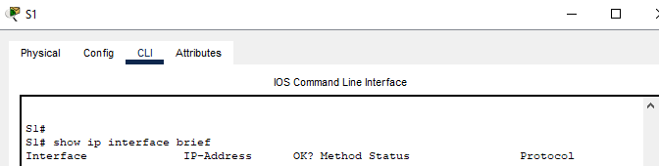

* + 1. **Record the interface status for the following interfaces.**

| Interface | S1 Status | S1 Protocol | S2 Status | S2 Protocol |
| --- | --- | --- | --- | --- |
| F0/1 | YES | up | YES | up |
| F0/6 | YES | up | YES | down |
| F0/18 | YES | down | YES | up |
| VLAN 1 | YES | up | YES | up |

* + 1. **Q: From a PC, ping S1 and S2.** The pings should be successful.

Was the ping successful? Yes

What was the RTT?

S1: Minimum = 0ms, Maximum = 9ms, Average = 2ms

S2: Minimum = 0ms, Maximum = 1ms, Average = 0ms

* + 1. **Q: From a switch, ping PC-A and PC-B**. The pings should be successful.

Was the ping successful? Yes

What was the RTT?

PC-A: Success rate is 100 percent (5/5), round-trip min/avg/max = 0/0/0 ms  
PC-B: Success rate is 100 percent (5/5), round-trip min/avg/max = 0/0/0 ms

* TAKE A SCREENSHOT OF YOUR OUTPUTS

# Reflection Question

(1): Why are some FastEthernet ports on the switches are up and others are down?

***Type your answer here:*** FastEthernet ports are up for the connections that we have set up between both devices. For example, S1 and PC-A – we connected them through FastEthernet port 0/6 which shows up in the information brief. PC-B was connected to S2 with FastEthernet port 0/18, and is not connected in any physical way to S1, hence the status shows as “down”. We have also setup vlan and port 0/1 on both Switches hence the status is “up”.

(2): What could prevent a ping from being sent between the PC?

***Type your answer here:*** If the devices were not configured properly, for example wrong IP addresses or gateway. Ping would not be possible if the device was turned off as well.

***(3):*** What did you learn from completion of this lab

***Type your answer here:*** I have learnt how to make a basic switch – pc connectivity, how to configure both devices to ensure connection is successful. I have also had a recap on setting up hostname, password, secret (encrypted password) and banner for each switch privileged mode. I learnt few new commands like “sh run”, and shortcut “no shut” for “no shutdown”.

***(4):*** What problems did you encounter as you progressed through this lab

***Type your answer here:*** I got confused when entering banner message, I forgot it had to be all done in one line. This resulted in my banner to be messy for S1. To troubleshoot I used a question mark to see what is the syntax to set it up. Even thought banner for S1 is messy, I was able to successfully do it on S2 as expected.

***Theory Questions:***

***(you may use alternative sources for solutions, however you must reference the source of your material)***

***(5): What are the characteristics of an IPv4 network address?***

IPv4 is a 32 bit integer number that is presented in decimal form – for example: 192.168.1.10. As seen on the example, it is four numbers separated by full stop. The range is between 0-255. There are few IP addresses that are reserced for subnet/private network/hosts. There is limited amount of IPv4 this is why IPv6 was introduced.

***(6): What are the characteristics of an IPv6 network address?***

IPv6 is a 128 bit address which is presented as 8 hexidecimal numbers separated by colon – for example ABCD:EF:1234:56GH:ABCD:EF:1234:56GH. There is bigger address availability vs IPv4, IPv6 seems to be more reliable.

***(7): What additional characteristics are available with IPv6 that are aimed at better QoS provisioning?***

TCF (Traffic Class Field) which is 8-bit field in the header dedicated to QoS. This allows packets to be classified and prioritized based on traffic type (eg. data, video, call)

Low Label which is 20 bit field that identified and manages traffic flow.

Simplified header structure vs IPv4, it allows faster processing and lot latency

Reference used: https://www.sciencedirect.com/science/article/pii/S1877050914006139

***(8): Define a subnet mask and what it is used for.***

Subnet Mask splits IP address into sections – network and hosts. It shows which part of the IP is for the whole network and which for individual hosts. This helps to manage and organize network better. Example of subnet mask 255.255.255.0